Переклад з української мови на англійську мову
Translation from Ukrainian into English

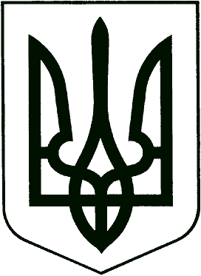

UKRAINE

JUNIOR SPECIALIST´S degree
DIPLOMA

A No.132973
Derzhznak. Ukraine Printing Company. Order 4-3220, 2004
CK No. 25662463 | DIPLOMA  with honors  Shcherbakova  Larysa Oleksandrivna  graduated in 2004 from Vocational School of Industrial Automatics of Odesa State Academy of Refrigeration majoring in “Operation of Information and Decision-Making Processing Systems” and was qualified as Technician-Programmer.  Rector /signature/ V. V. Prytula  July 03, 2004  Official Seal:  Ministry of Education and Science of Ukraine* 02071085* Odesa State Academy of Refrigeration*

